Team Project EDA

Accident Severity
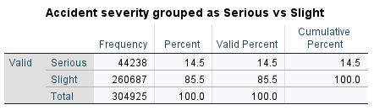
The frequency distribution of accident severity, grouped into serious and slight categories, reveals a clear class imbalance. Most accidents (85.5%) are classified as slight, while only 14.5% are serious. This suggests that most road accidents result in minor outcomes, but a minority still lead to more severe consequences.
This imbalance is important for both descriptive and predictive analysis. From a descriptive perspective, the statistics show that serious accidents are relatively rare events. From a modelling perspective, the imbalance can bias predictive models toward the majority class, reducing their ability to accurately identify serious accidents.
Hour of the day
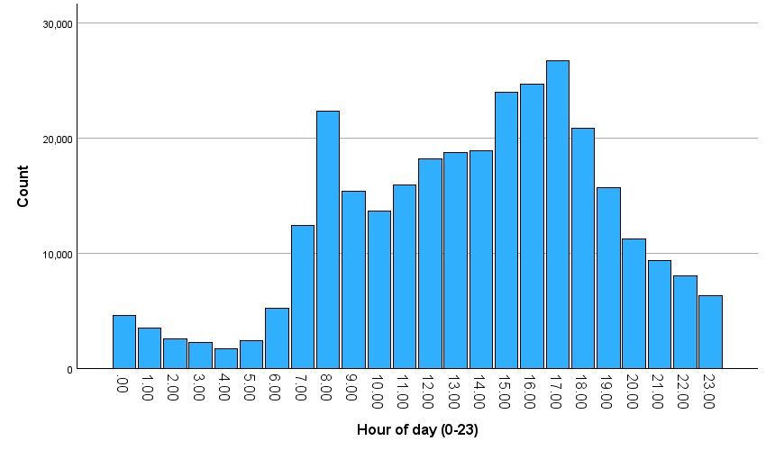
The distribution of accidents across the hours of the day shows clear temporal patterns. Accident frequency is lowest during the early morning hours (00:00–05:00), reflecting reduced traffic volume during these times. From around 06:00 onwards, accident counts begin to increase significantly, as this would be when people start going to work/school.

Accident frequency continues to rise throughout the day, reaching a peak between approximately 16:00 and 18:00. This peak likely represents evening rush hour, where increased traffic congestion, driver fatigue, and time pressure of wanting to get home faster contribute to a higher likelihood of accidents. After this period, accident counts gradually decline into the evening and night.
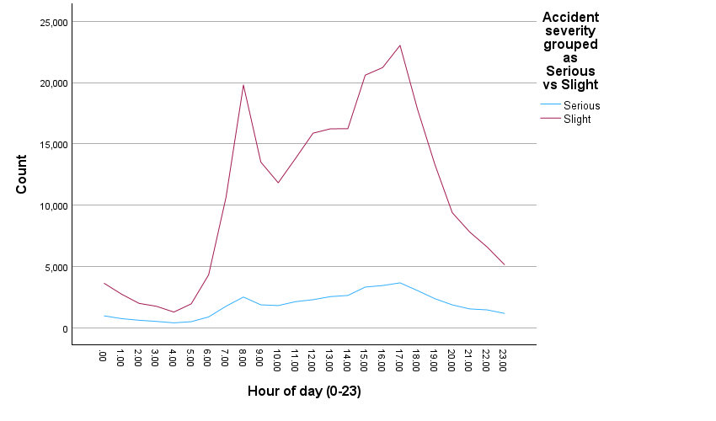

When separating accidents by severity, both serious and slight accidents follow a similar overall pattern throughout the day, with peaks occurring during commuting hours. However, slight accidents occur at a much higher frequency than serious accidents across all time periods.
Serious accidents show a more gradual increase throughout the day, peaking in the late afternoon. This suggests that while the number of accidents increases due to traffic volume, the likelihood of severe outcomes may also be influenced by factors such as higher speeds, fatigue, and reduced attention during peak travel times.
In contrast, slight accidents show sharper increases during peak hours, particularly in the morning and late afternoon. This may be due to stop-start traffic conditions, congestion, and minor collisions that are more common in high-density traffic environments.

Overall, even though both accident types peak at similar times, the consistently higher number of slight accidents highlights that increased traffic volume primarily leads to more minor collisions rather than severe incidents.

Accidents By Months
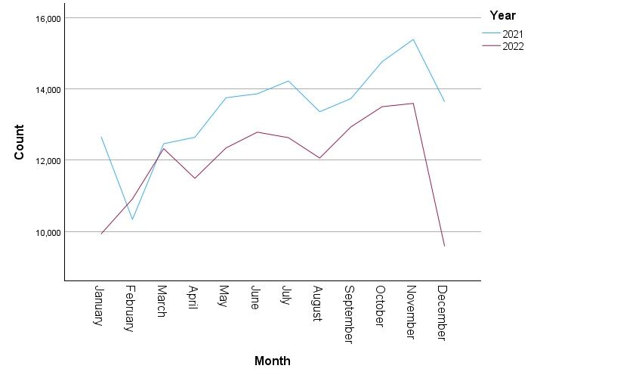
The line graph shows the distribution of accidents across months for both 2021 and 2022, highlighting clear seasonal patterns. In both years, accident frequency generally increases from the beginning of the year, reaching higher levels during the middle and later months.
Accident counts rise steadily from spring into summer, with a slight dip around August, before increasing again towards autumn. The highest number of accidents occurs between October and November, suggesting that factors such as reduced daylight hours, worsening weather conditions, and increased road usage may contribute to higher accident frequency during this period.
A similar overall trend is observed for both years, indicating consistent seasonal patterns in road accidents.
Important note for analysis
A noticeable drop in accident frequency can be seen in December 2022, which differs significantly from the pattern seen in 2021. This is because December 2021 recorded 13,646 accidents, whereas December 2022 recorded only 9,595. This sharp decline is unlikely to represent a real-world decrease and is more due to incomplete data for that month.
This highlights a limitation in the dataset, as incomplete temporal coverage may distort seasonal trends and reduce the reliability of year-to-year comparisons.
Overall, the analysis suggests that accident frequency is influenced by seasonal factors, with higher accident rates occurring in autumn months.

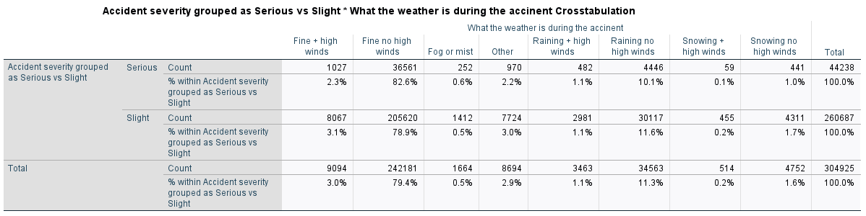
Weather Conditions
The crosstabulation between accident severity and weather conditions shows that most accidents occur during fine weather, particularly when there are no high winds. For example, 82.6% of serious accidents and 78.9% of slight accidents occur under fine weather conditions without high winds.
Rainy conditions, especially without high winds, account for a decent proportion of accidents, with 10.1% of serious accidents and 11.6% of slight accidents occurring in these conditions. On the other hand, accidents occurring in more extreme weather conditions such as snow or fog represent a much smaller proportion of total accidents.
Although it may seem unexpected, the higher number of accidents in fine weather is likely due to increased traffic volume, as more people choose to travel under favourable conditions. In contrast, adverse weather conditions such as snow or heavy rain may reduce the number of vehicles on the road, leading to fewer total accidents.
However, while fewer accidents occur in poor weather, these conditions may still increase the risk of more severe accidents due to reduced visibility and poorer road surface conditions.
Weather Conditions Statistical Significance
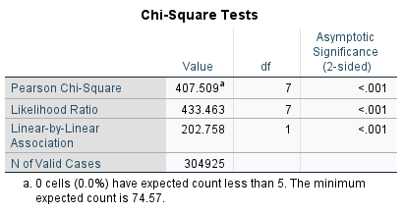
The chi-square test results show a statistically significant relationship between weather conditions and accident severity (χ²(7) = 407.509, p < .001). This indicates that accident severity is not independent of weather conditions, and that weather plays a role in influencing the severity of road accidents.
Additionally, no expected cell counts were below 5, meaning the assumptions of the chi-square test are satisfied and the results are reliable.
Urban VS Rural
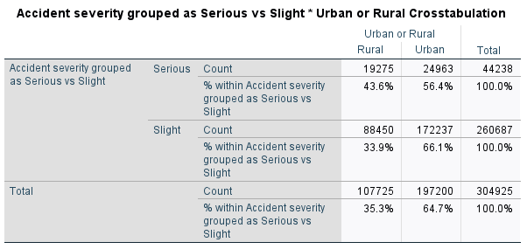
The crosstabulation between accident severity and location (urban vs rural) shows clear differences in severity distribution. While most accidents occur in urban areas (64.7%), rural areas account for a higher share of serious accidents.
Specifically, 43.6% of serious accidents occur in rural areas, compared to only 33.9% of slight accidents. On the other hand, urban areas account for 56.4% of serious accidents but a higher proportion of slight accidents (66.1%).
These results suggest that accidents in rural areas are more likely to be severe compared to those in urban areas. This may be due to several factors, including higher speed limits, reduced road lighting, fewer traffic control measures, and longer emergency response times in rural environments.
Overall, urban areas tend to experience more accidents overall due to higher traffic density, but these are more likely to be minor due to lower speeds and congestion.

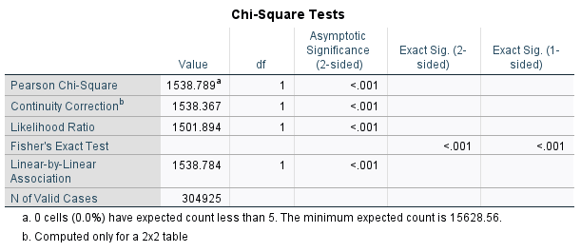
A chi-square test confirms a statistically significant association between accident location and severity (χ²(1) = 1538.789, p < .001). This indicates that accident severity is strongly related to whether the accident occurs in an urban or rural area.
The test assumptions are satisfied, as no expected cell counts are below 5, and the large sample size ensures the reliability of the results
Speed Limit
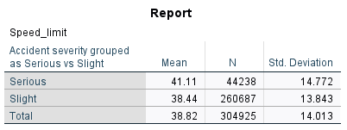
The analysis of speed limit by accident severity shows a clear difference between serious and slight accidents. The mean speed limit for serious accidents is 41.11 mph, compared to 38.44 mph for slight accidents. This indicates that on average more severe accidents tend to occur in higher speed environments.

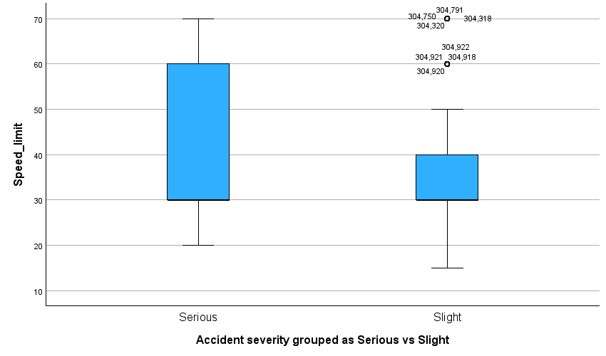
The boxplot further supports this relationship, showing that the distribution of speed limits for serious accidents is generally higher than slight accidents. The median speed for serious accidents appears higher, and the interquartile range extends into higher speed limits, particularly towards 60–70 mph.
Although, slight accidents are more concentrated at lower speed limits, typically between 20–40 mph, which are more common in urban environments.

These findings suggest that higher speed environments are associated with more severe accident outcomes. This is consistent with real-world expectations, as higher speeds result in greater impact forces, increasing the likelihood of serious injury.
Lower speed environments, such as urban areas, tend to produce more accidents overall, but these are more likely to be minor due to reduced speeds and increased traffic congestion.
Causality Group
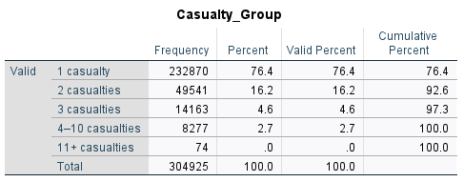
The frequency distribution of the number of casualties per accident shows that most accidents involve a single casualty. Specifically, 76.4% of all accidents involve only one casualty, making this by far the most common outcome.
Accidents involving two casualties account for 16.2% of cases, while three-casualty accidents represent 4.6%. Incidents involving larger numbers of casualties are relatively rare, with only 2.7% involving between 4 and 10 casualties, and almost none (0.0%) involving more than 11 casualties.
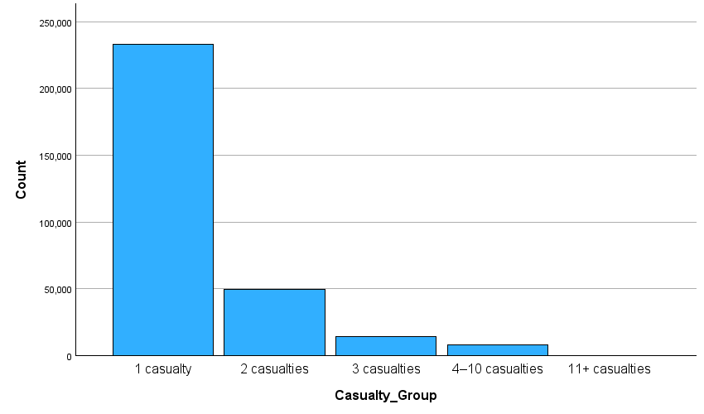

This bar chart clearly illustrates a steep decline in frequency as the number of casualties increases. There is a strong right-skewed distribution, where low-casualty incidents are extremely common and high-casualty incidents are rare.
This indicates that most road accidents tend to involve individual vehicles or small groups, rather than large-scale incidents.
This indicates that while multi-casualty accidents do occur, they are relatively rare compared to single-casualty incidents. However, these larger incidents may have greater overall impact and should be considered important for safety planning.
These findings suggest that while accidents are frequent, they typically result in a limited number of casualties. This may reflect common accident types such as minor collisions or single-vehicle incidents.
However, although multi-casualty accidents are rare, they may have a significantly greater overall impact in terms of severity and emergency response requirements.
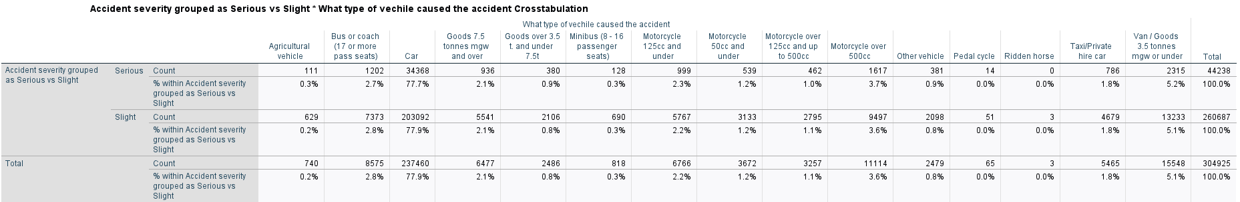
Vehicle Type

The crosstabulation between accident severity (grouped as serious vs slight) and vehicle type shows that cars account for the vast majority of accidents. Specifically, cars are involved in 77.7% of serious accidents and 77.9% of slight accidents, making them the most common vehicle type across all accident categories.
Other vehicle types, such as vans (5.2% of serious accidents), motorcycles (varying between approximately 1–4%), and buses or goods vehicles, contribute a much smaller proportion of total accidents. Categories such as pedal cycles, ridden horses, and agricultural vehicles account for a negligible proportion of accidents.

The similar percentage distributions across serious and slight accidents suggest that vehicle type does not strongly differentiate between accident severity in this dataset. For example, the proportion of car-related accidents is almost identical for both serious and slight categories.
This indicates that the high number of car-related accidents is likely due to their dominance in overall road usage rather than an increased likelihood of causing more severe accidents.
Vehicle type appears to have a limited influence on accident severity when compared to other factors such as speed, location (urban vs rural), or time of day.

Lighting Conditions
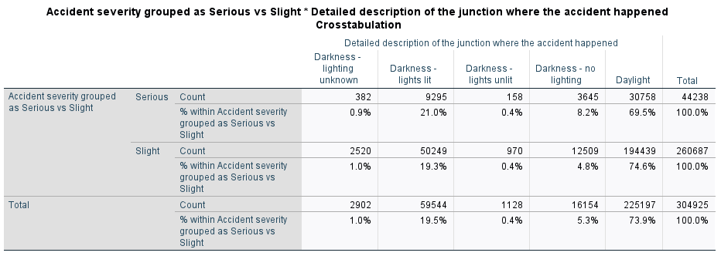
The crosstabulation between accident severity and light conditions shows that most accidents occur during daylight conditions. Specifically, 69.5% of serious accidents and 74.6% of slight accidents occur in daylight.
Accidents occurring in darkness with street lighting account for a decent proportion of incidents, representing 21.0% of serious accidents and 19.3% of slight accidents. On the other hand, accidents in darkness without lighting are less common overall but still present, accounting for 8.2% of serious accidents compared to 4.8% of slight accidents.
Other categories, such as darkness unknown or unlit conditions, contribute only a very small proportion of total accidents.
Although most accidents occur during daylight, this is likely due to higher traffic volumes during daytime hours. However, the proportion of serious accidents is relatively higher in darker conditions, particularly where there is no street lighting.
For example, accidents in darkness without lighting make up a greater share of serious accidents (8.2%) compared to slight accidents (4.8%). This suggests that poor visibility may increase the likelihood of more severe outcomes.

Finally, daylight conditions have the highest number of accidents overall, darker conditions (without lighting) appear to be associated with a higher relative risk of serious accidents.

Road Type
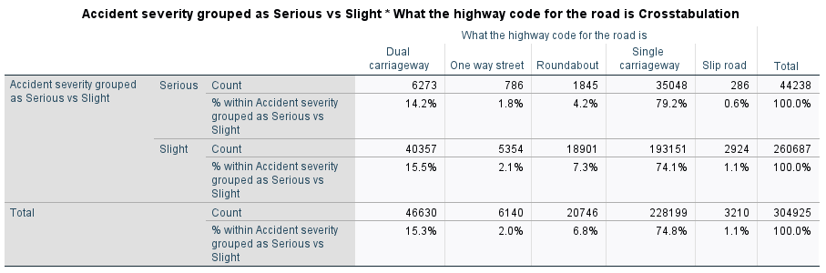
The crosstabulation between accident severity (grouped as serious vs slight) and road type shows that most accidents occur on single carriageway roads. Specifically, 79.2% of serious accidents and 74.1% of slight accidents take place on single carriageways, making this the most common road type for accidents overall.
Dual carriageways account for a smaller proportion of accidents, representing 14.2% of serious accidents and 15.5% of slight accidents. Roundabouts contribute 4.2% of serious accidents and 7.3% of slight accidents, while one-way streets and slip roads account for only a small proportion of total accidents.

The results suggest that single carriageway roads are associated with a higher proportion of serious accidents compared to other road types. This may be due to factors such as higher speed limits, the presence of opposing traffic, and fewer physical barriers separating vehicles.
In contrast, road types such as roundabouts and one-way streets show a higher proportion of slight accidents, which may reflect lower speeds and traffic control measures that reduce the severity of collisions.
Overall, most accidents occur on single carriageways due to their prevalence in the road network, but they also appear to carry a higher relative risk of serious accidents compared to other road types.

Final Analysis

The exploratory data analysis identified several key patterns in road accident frequency and severity. Temporal analysis showed that accidents are strongly influenced by time of day, with peaks occurring during morning and evening commuting hours. Seasonal trends were also observed, with higher accident frequencies in autumn months, although some anomalies (such as December 2022) highlighted limitations in data completeness.
Environmental factors such as weather and light conditions showed statistically significant relationships with accident severity. However, their practical impact appeared limited, as differences between categories were relatively small. This suggests that while these factors influence driving conditions, they are not the primary determinants of accident severity.
In contrast, location and speed-related variables demonstrated stronger relationships with severity. Rural areas were associated with a higher proportion of serious accidents compared to urban areas, likely due to higher speeds and reduced infrastructure. Similarly, higher speed limits were linked to more severe accidents, reinforcing the importance of speed as a key factor in accident outcomes.
Road type analysis further supported these findings, with single carriageways showing a higher proportion of serious accidents, likely reflecting their association with higher-speed, rural environments. Meanwhile, variables such as vehicle type showed relatively weak differences between severity categories, suggesting that vehicle involvement alone does not strongly determine accident severity.
The analysis also revealed that most accidents involve a small number of casualties, with over three-quarters involving only one casualty. This indicates that while accidents are frequent, they are typically low-impact events, although a smaller number of multi-casualty incidents may have greater overall consequences.
Overall, the findings suggest that accident severity is more strongly influenced by behavioural and environmental factors—such as speed, location, and traffic conditions—than by individual characteristics such as vehicle type or weather alone. These insights provide a strong foundation for further predictive modelling and support the development of targeted road safety strategies.

